METCOM 9-1-1
Governing Board Meeting Minutes
April 14, 2026

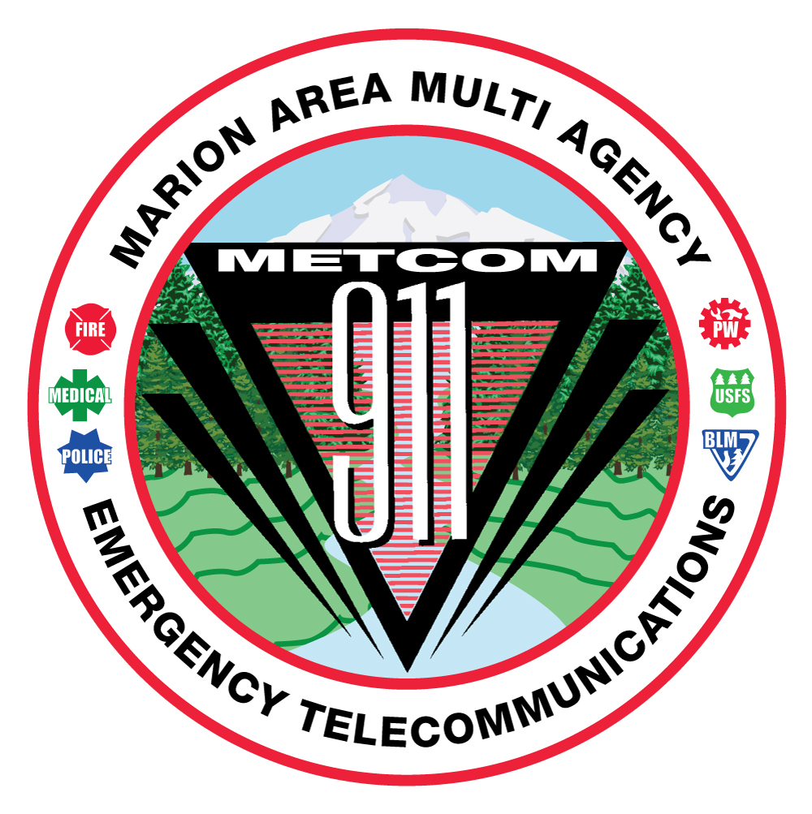

MEMBERS IN ATTENDANDANCE:
Sherry Bensema
Mike Corless
Mark Daniel
Levi Eckhardt
Damian Flowers
Alan Hume
Leslie Jackson
Bill Miles
Jason Millican
Dan Mullen
Don Parise
Jim Trierweiler
Keith Veit

METCOM:
John Thompson
Rosa Antoine

Others in Attendance:
Christ Tate, Day Wireless
Brian Nichols, MCPW

METCOM regular Governing Board meeting called to order at 10:05 AM by Mark Daniel.
The March 10, 2026, Board meeting minutes were provided to Board members via email and available in hard copy form or by request at the meeting. Board Chair, Mark Daniel, asked members if there were any changes to the minutes provided. None were voiced. The motion to accept the minutes was made as follows:
- Motion to accept the March 10, 2026, Board Meeting minutes; Levi Eckhardt
- Second by Jason Millican
- Discussion: None. Motion passed all in favor, no opposition.

METCOM Budget:
Director John Thompson shared that he met separately with METCOM’s police users and fire users to discuss new fee formulas. The police users agreed on a formula, which has been accepted by all police user agencies. The formula for user fees is 20% based on population and 80% based on call volume. This fee formula will go into effect in fiscal year 2027/28.

The fire user agencies are still in discussion and have been looking at a few options for fee formulas. Fire agencies will pick the discussion back up this fall, potentially September or October. The potential merger of Mt. Angel Fire and Monitor Fire Districts could have some impact.

Chief Trierweiler shared that they are optimistic that the merger will go through. Signatures are due this month in order for the measure to be included on the November ballot.

Marion County Radio Project:

Brian Nichols shared that site improvements are progressing and that they are building radio towers. There are improvements at seven radio sites, and all are under construction except for the Wipper site, which requires ground anchors. Although, we are probably three weeks away from breaking ground on that site.

There are no changes to radio designs. Five of the sites won’t have RF antennae, just data. They are currently working with an IT designer. Install is starting in July or August and Marion County Sheriff’s Office will be brought onto the new system first. Once they have 30 days of continuous service, they will begin bringing on additional agencies.

Chief Daniel asked if MCSO is having any issues since they’ve started using the new Tait radios. Brian replied that they did identify an issue with the knobs that they are addressing now.

Director Thompson asked about the existing funding gap and if there were any resolutions. Brian replied that he had been looking at grants and had submitted a congressional spending request that hadn’t been picked up. He plans to ask for $2 million in fall session; however, those take six months to come through so we wouldn’t have that funding until the end of 2026/27 fiscal year.

Director Thompson asked if there are any concerns about ARPA funds not being spent. Brian said that only 50% of the funds had been spent, but no concerns on the remainder being used in the required timeline.

Director Thompson asked if there are any anticipated changes to the subscriber fees. Brian said that those fees are solid. He added that he can’t move everyone onto the system until he buys the radios. This was originally slated to happen during 3rd quarter of the 2026/27 fiscal year but thinks it will be bumped out to 4th quarter (possibly June 2027) for METCOM user agencies instead. He also believes that we should have quick turnaround from Tait once the radios are ordered.

Director Thompson asked about the availability of radios to borrow when there are larger events, such as Oktoberfest. Would those agencies be able to rent or borrow extra radios from a cache? Brian said that there will be approximately 40 radios available in the cache that would be used to swap out or borrow from.

Assistant Chief Corless asked if agencies who already have the new radios can they swap over to the new system sooner. Brian said that is a possibility but that there would be some issues when that agency needs to communicate with agencies/units on the conventional system.

Assistant Chief Corless then asked what the prospective date is and Brian responded early 2027.

Brian also shared that they are still looking at rate implementation.

Director Thompson asked if there is anything else needed from METCOM or METCOM user agencies. Brian asked that fire users help identify firefighter grants or provide insight to him on identifying them. Otherwise, they are just plowing ahead.

Open Agenda:

EMS Coordinator Bensema asked if we have reached an agreement on the Wipper Site. Director Thompson said that there isn’t one in writing quite yet but there is an agreement and he will send it out.

Director Thompson shared that he met with ADCOMM last week and toured multiple radio sites. This was to gather further information to ensure equipment needs are met for the new radio console install.

Various discussions about testing and radio patches versus moto bridge. Assistant Chief Corless shared that he had experience with this at Estacada Fire and that it worked well and could be a good solution. Director Thompson will start looking into this option and possibly do some testing of it. Chris from Day Wireless will also do some research.

Chief Flowers asked if Brian is looking at year two costing. There was a general discussion and concern about control and costing of this radio system/project. Director Thompson will follow up with Brian Nichols and get information on this in writing. He will also reach out regarding any changes on pricing if this contract price expires – what are the options if this happens?

Chair Mark Daniel closed the meeting and adjourned at 10:44 am.

Future Meeting Dates:
To be scheduled.

